Machine cell formation for dynamic part population considering part operation trade-off and worker assignment using genetic algorithm

1. Model
The problem to be solved is implemented using a Model class that holds the values related to the problem including machine types, worker types, machine working capacity and etc. Also it contains methods to calculate the cost and check the constraints of any solution given, which will be computed according to the Model Parameters and attributes. The following introduce the notations and parameters that are used in the model.

Index Sets:

p | {p = 1, 2, 3, …, P} | Part types.
k | {k = 1, 2, 3, …, Op} | Operation k of part type p.
m | {m = 1, 2, 3, …, M} | Machine types.
c | {c = 1, 2,3, …, C} | Manufacturing cells.
t | {t = 1, 2, 3, …, T} | Time periods.
w | {w = 1, 2, 3, …, W} | Worker type.

Model Parameters:
A_{mc}(t) Number of machine type m available in cell c at time period t.
A_{wc}(t) Number of worker type w available in cell c at time period t.
D_{p}(t) Demand for part type p at time period t.
t_{kpmw} Time required to perform operation k of part type p on machine type m with worker type w.
IE_{p} Intercellular material handling cost per part type p.
IA_{p} Intracellular material handling cost per part type p.
B_{U} Upper cell size limit.
B_{L} Lower cell size limit.
α_{m} Amortized cost of machine type m per period.
β_{m} Operating cost per hour of machine type m.
δ_{m} Relocation cost of machine type m including uninstalling, shifting, and installing.
T_{m} Capacity of each machine type m in hours.
T_{w} Capacity of each worker type w in hours.
μ_{kp} Production cost of operation k of part type p.
o_{kp} Subcontracting cost of operations k of part type p.
S_{w} Salary cost of worker type w.
H_{w} Hiring cost of worker type w.
F_{w} Firing cost of worker type w.
These parameters are saved in a dictionary attribute in the Model class which is initiated randomly when the class is instantiated. The notations are similar to the above, for instance A_{mc}(t) is a method named Amct.
2. Genetic Algorithm

The application of genetic algorithms in machine cell formation for dynamic part population, while considering part operation trade-offs and worker assignment, provides a powerful and efficient solution. By leveraging the principles of natural selection and genetic variation, the genetic algorithm can optimize the allocation of parts to machines and workers, taking into account various factors such as part complexity, operation time, and worker skills. This approach enables the creation of dynamic and adaptable machine cells, which can efficiently handle changing part populations and operational requirements. The genetic algorithm's ability to explore a vast search space and converge on optimal solutions makes it a valuable tool in optimizing machine cell formation, leading to improved productivity and resource utilization in manufacturing systems.

2.1 Solution representation schema
In the solution representation schema, three matrices [PMpk], [PWpk] and [PCpk] are implemented in each period segment of the planning horizon, denoting allocation of part-operation to machine type m, worker type w, and cell type c. Remember that each operation for any part will be assigned only one cell, one type of worker and also one type of machine. By combining the three matrices described above, the solution representation schema is shown in Figure 1.
However this is the schema shape used in the Model, for the genetic algorithm it is reshaped into a 2D array using numpy.reshape method.
An important point to consider is that this schema or data representation will be the only data of a solution and the genetic algorithm will be applied on this schema. Therefore any decisions regarding the problem must be calculatable using this schema. For instance number of workers available, the number of newly hired workers or even the number of parts to be produced during any period. They all are to be calculated from this schema. For every period of the problem, this schema will be appended to the solution and therefore a problem’s solution with 2 periods of time will have two items, first for the period one and the other for the period 2.
In the second matrice meaning [PW], workers are either a natural number determining the worker type, or 0 which means no worker is assigned to the part operation and therefore the part operation is subcontracted.

Decision Variables:
These variables are calculated using the schema.
- Xkpmwct method checks if PMpk equals m, PWpk equals w and PCpk equals c. If so it will return 1.
- OPkpt method uses is_subcontracted method to find operations with worker equal to 0, then the number of parts to be produced is assumed to be equal to Dpt, the demand, whether it is subcontracted or produced internally.
Other variables are calculated using these basic variables.

2.2 Initialization of population
For the algorithm to start, we must feed it with generation zero which is created completely randomly. Since this can violate the model’s constraints, it goes through Emendation Operation to fix the violations.
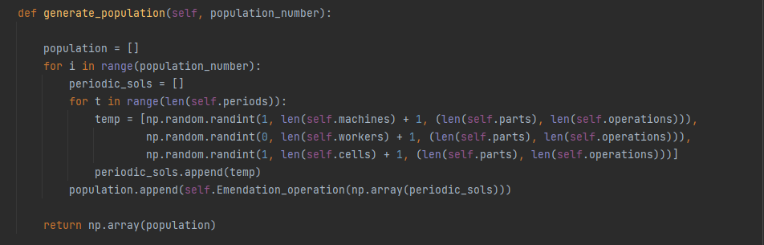

2.3 Fitness assessment
Fitness is assessed using fitness_func method that uses calculate_cost method to calculate multiple factors that determine a solution’s cost.
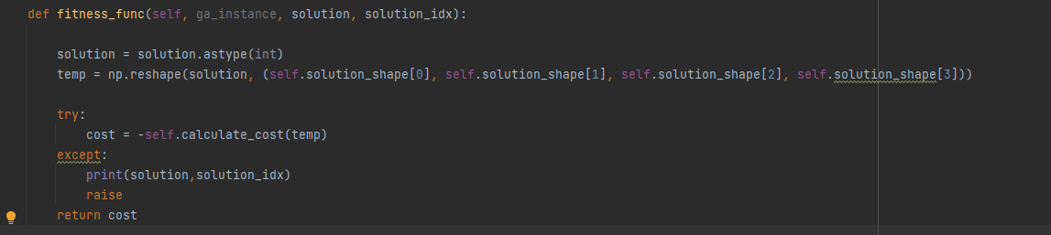
The cost value is made negative because the algorithm works to increase fitness.

The factors to calculate cost are the following equations.

These constraints are checked in the check_constraints method that calculates the Boolean value regarding each equation.

2.4 Genetic operators

2.4.1 Parent selection
After evaluating the fitness of the parent solutions in the population, better performing solutions are selected to produce the descendants. Parent solutions with higher fitness value have a higher chance of being selected more often. The selection is made by playing binary tournament between solution sets according to their fitness value.

2.4.2 Crossover or recombination
Crossover is performed between two selected parent solutions which create two new descendant solutions by exchanging segments of the parent solutions, thus descendant solutions retain partial properties of the parent solutions. Figure 2 depicts the solution sets of parents 1 and 2 selected for crossover. For crossover, the selection of segments can be row-wise or column-wise following the matrix limits and the crossover probabilities.

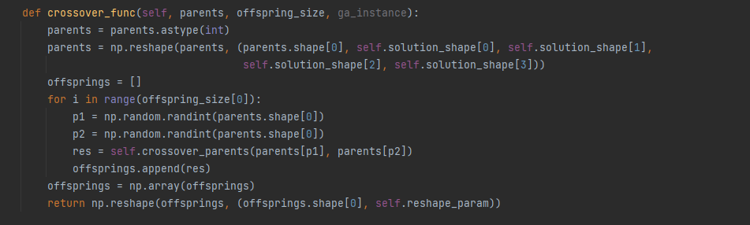

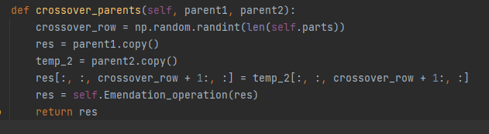

2.4.3 Mutation
The mutation is performed to maintain the diversity in the solutions. The mutation operator is carried out on parent solutions with a low probability of occurrence. The operator can be implemented by inverting the segment of a solution schema and place the mutated content in the reverse order, as shown in Figure 3.

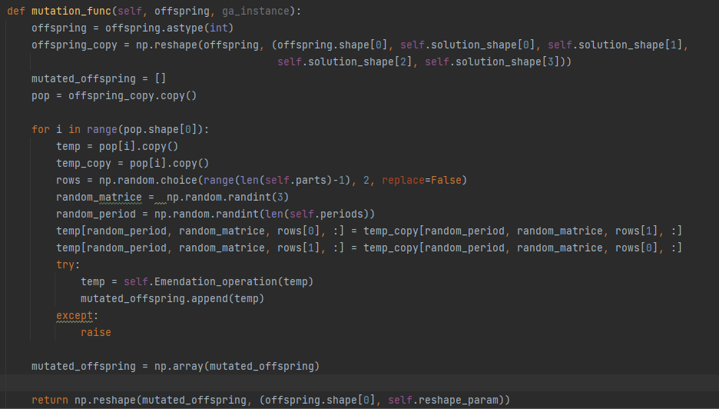
2.4.4 Emendation operation
The crossover and mutation operations may distort solution set by violating the cell size constraint, i.e., a few cells may have less than the minimum number of machine type while a few others may have specified more than maximum number of machine type. The emendation operation is performed on the distorted solution schema to preserve the cell size within the specified lower and upper bounds by moving parts from cell having maximum number of parts to cell having less than the minimum number of parts specified as per equation.
Emendation operation is only required for equation 8 since all the other are automatically applied during population generation and mutation and crossover.

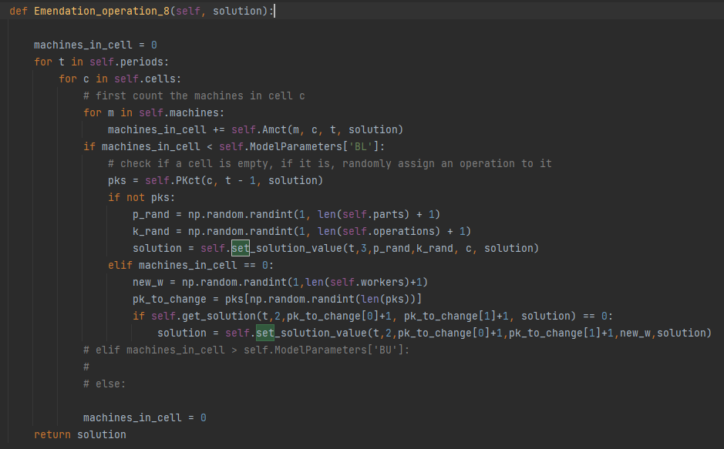

2.4.5 Termination of algorithm
The algorithm continues to generate the solution sets of descendants until a criterion for termination is met. A single criterion or a set of criteria for termination can be adopted.
In this case the termination criterion is the maximum number of iterations, i.e., the algorithm stops functioning when a specified number of iterations is reached which is generations.

